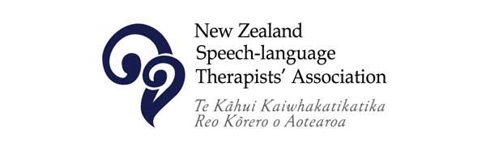
Towards Equity for Māori
A guide for SLTs working in Aotearoa

Contents

Whakapapa 3
Nau mai haere mai
An introduction 4
An open letter to NZ SLTs 5

Ngā Pou 6
Kete Mātauranga
Bias, Racism, and Anti-racism 7
NZ History and the articles of Te Tiriti o Waitangi 9
Wairuatanga: Te Ao Māori, including Te Reo Māori, Tikanga, & Mātauranga Māori 10
Rangatiratanga 12
Oritetanga 13

Whakapapa
While created for SLTs working in Health, this document was gifted to the Association for distribution and sharing with members and to maintain and update as we continue to evolve as a profession.
This document was born from many conversations with many people over several years. When we listen to the experiences of Māori, and more importantly, believe what we are told, we will hear that the learning and unlearning required about this place we call home is an essential starting point for Pākeha and Tauiwi SLTs if we want to create spaces where our kaimahi Māori feel excited and supported to come to work.
Many hands have touched this document in its journey to this current version. The initial working group comprised Biddy Robb, Adele Siave, Gwen Kerrison, Libby Coates, and Aoife O’Reilly.
In particular, we want to acknowledge the wahine Māori who continue to embody manaakitanga as they help steer the waka for our profession on this journey and who shared their whakaaro with us in creating this document – Nicky-Marie Kohere Smiler, Hana Tuwhare, Katrina McGarr, and Karen Brewer.
We also want to acknowledge some key documents that shaped the foundations of this one:
Equity of Healthcare for Maori: A framework
Ka Hikitia Support Document: Ministry of Education
Maori-Crown Relations Capability Framework: Te Arawhiti

The hīkoi has begun.
Nau mai, haere mai

This framework reflects the journey that our profession is on towards decolonising and indigenising the kaupapa of speech-language therapy practice and acknowledges that as we mature as a profession, these pillars may well change and develop over time.
As we work towards indigenising speech-language therapy practice, we must first be willing to understand the historical context of this place, how our colonial past has shaped, and continues to shape, the healthcare landscape that we now work within, and how racism shows up within this system, our clinical practice, and indeed ourselves. This work requires a willingness to continue to learn, to sit in the discomfort of unlearning ways of knowing and doing, and to challenge racism everywhere we find it, including within ourselves.
For this reason, this framework contains five pou, or pillars:
- Bias, Racism, and Anti-Racism
- NZ History and the articles of Te Tiriti o Waitangi
- Wairuatanga: Te Ao Māori, including Te Reo Māori, Tikanga, and Mātauranga Māori
- Rangatiratanga: Partnership and Engagement
- Oritetanga: Quality & Equity

As Pākeha and Tauiwi staff, we have work to do in creating spaces for our kaimahi and whānau Māori to thrive. We can be a part of turning the waka of inequitable Health around. This process is more than a one-off workshop on the articles of Te Tiriti o Waitangi. It is a journey that will take many years and many hands. There is no test, no exam, and no mandated requirement to work through this framework beyond that incorporated in the NZSTA Continuing Professional Development Framework requirements, but we hope that as a citizen of Aotearoa, you will take up the wero of being part of a reckoning and a new way forward for our profession.
This guide is in no way perfect and will inevitably change as our collective understanding grows and changes. There is much to learn beyond these objectives, and the resources available to support your learning are many. These are merely the fundamental things we believe are essential for every SLT working in Health, and we have tried to guide you with some good resources to start your kete mātauranga.
To begin, we encourage you to read this open letter to our profession, shared here with permission:
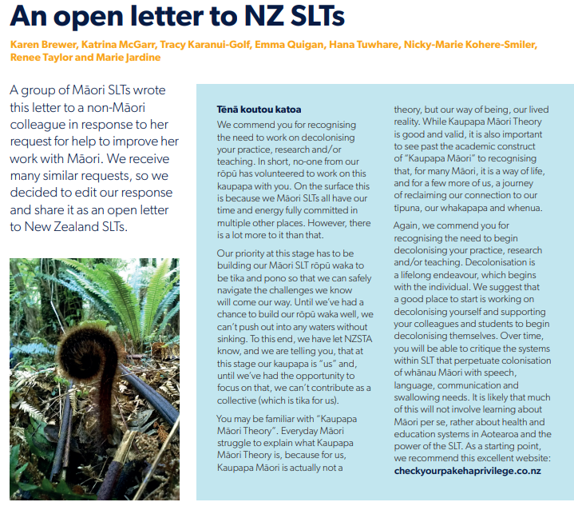
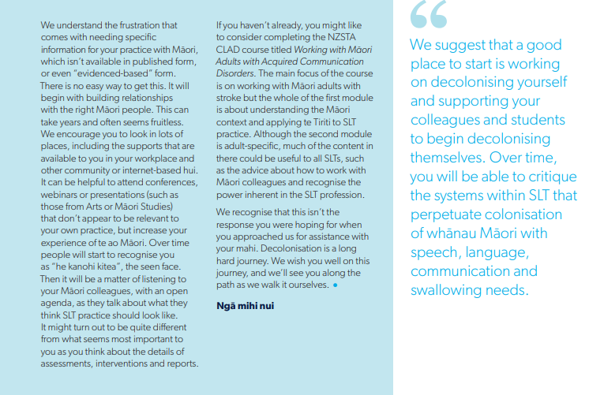

We suggest that a good place to start is working on decolonising yourself and supporting your colleagues and students to begin decolonising themselves. Over time, you will be able to critique the systems within SLT that perpetuate colonisation of whānau Māori with speech, language, communication and swallowing needs.
“
Ngā Pou
Bias, Racism, and  Anti-Racism | SLTs will be aware of their own biases, how these contribute to institutional racism in healthcare, and how institutional racism contributes to inequity for Maori | - SLTs will engage in regular CPD about unconscious bias and institutional racism  - SLTs will demonstrate awareness of their own biases that contribute to discrimination for Māori  - SLTs will actively reflect on, and share, individual experiences in achieving health equity for Māori  - SLTs will actively work to become anti-racist
NZ History & Te Tiriti o Waitangi | SLTs will demonstrate an understanding of Aotearoa’s history and the impact of this on healthcare | - SLTs will demonstrate a contemporary understanding of He Whakaputunga, Te Tiriti o Waitangi  - SLTs will seek to understand the historical and ongoing impacts of colonisation, and the role of decolonisation in Healthcare equity  - SLTs will be able to explain how their clinical practice aligns with the articles of Te Tiriti o Waitangi
Wairuatanga | SLTs will value and seek knowledge from Te Ao Māori to support their practice | - SLTs will understand and demonstrate use of Māori models of Health and wellbeing (e.g. Te Whare Tapa Wha, Hui Process, Meihana Model)  - SLTs will seek out and use available evidence-based practice and Mātauranga Māori that promotes Health equity for Māori within their clinical area
 | SLTs will protect, nurture, and use te reo Māori within clinical practice | - SLTs will include development of te reo Māori in their professional development plans, relative to their current level of ability
 | SLTs will be aware of and integrate tikanga relevant to their clinical practice | - SLTs will engage with learning opportunities to develop knowledge and understanding of Tikanga Māori  - SLTs will demonstrate use of tikanga in clinical practice
Rangatiratanga | SLTs will actively develop relationships and partner with Māori Health Providers and/or initiatives within their clinical area | - SLTs will be familiar with Te Arawhiti partnership principles, and be able to articulate how and when to engage with Māori  - SLTs will demonstrate understanding of relevant Māori providers in their clinical area
Oritetanga | SLTs will be able to articulate how service improvements will contribute to closing the equity gap within their own clinical area | - SLTs will be aware of specific health inequities and predisposing factors that disadvantage Māori, as pertaining to clinical area  - SLTs will demonstrate knowledge of Whakamaua: Māori Health Action Plan 2020-2025  - SLTs will ensure ethnicity details are recorded correctly for Māori patients  - SLTs will be able to articulate equity data for their clinical area

Kete Mātauranga
Bias, Racism, and Anti-Racism
A foundational pillar of learning to be a good Tiriti partner is first examining our own beliefs, including those that are underpinned by fundamentally racist ideas and beliefs.
E ngaki ana a mua, e tōtō mai ana a muri
First clear the weeds, then plant.

This whakataukī speaks to the need to clear our minds of weeds that obscure our thinking before we consider joining our whānau Māori. Many of us were raised in a post-colonisation world, where colonial narratives dominated the discourse of both history and race relations.
It is easy to assume racism refers only to overt acts of hatred we can all recall. This section encourages an understanding that racism is about all of those things that discriminate against a group of people based on race. This includes not just overt interpersonal racism but also a recognition that racism is built into the structures of the organisations and systems we work within.
Finally, the readings in this section will help you to develop an understanding that it is not enough to be simply not-racist. If we want to be part of turning the waka of inequity around, we must work to become actively anti-racist, calling out racism wherever we find it, including within ourselves.

SLTs will be aware of their own biases, how these contribute to institutional racism in healthcare, and how institutional racism contributes to inequity for Māori
SLTs will engage in regular CPD about unconscious bias and institutional racism | HSQC Series: Understanding Bias in Healthcare:  Module One: Understanding and Addressing Implicit Bias  Module Two: Understanding Bias in Healthcare  Module Three: Experiences of Bias  Dr Camara Jones: The Gardener’s Tale  Check Your Pākeha Privilege website is a wealth of information, podcasts, books, and articles  Andrew Judd: Lessons from a Recovering Racist  Madeline Taylor: Waking Up to Whiteness  The land of the long white cloud  Ao Mai te Ra: Manatū Hauora
SLTs will demonstrate awareness of their own biases that contribute to discrimination for Māori | What springs to mind when you think of Māori in health? What underpins those initial thoughts? Is there another story to tell?  What are your own cultural norms around food/communication?  Can you think of a time when you and a whānau had different ideas about health? Whose ideas do you think were ‘right’?
SLTs will actively reflect on, and share, individual experiences in achieving health equity for Māori | Consider how you can build this into your team culture – share initiatives during team meetings, support your colleagues on their journey, chat about something new you’ve learned or reflected on over morning tea.
SLTs will actively work to become anti-racist | Dial a Māori and other mistakes Pākeha make  https://www.rcslt.org/learning/diversity-inclusion-and-anti-racism/programme-of-learning/#section-1  Tiriti-Based Futures series  Stop Institutional Racism

NZ History and Te Tiriti o Waitangi
It is essential to understand the history of this place we call home, and how the original arrival of the colonial settlers and the agreements by which they were granted access to this land has shaped our country since.
For a long time in Aotearoa, the health system focused on the three Ps – Participation, Protection, and Partnership – as the foundations of the Treaty of Waitangi. Current thinking is that this interpretation is reductionist. While it may reflect the intent of the English version of the Treaty of Waitangi, it does not reflect the Māori version of Te Tiriti o Waitangi, which is the prevailing text according to international law.

SLTs will demonstrate an understanding of Aotearoa’s history and the impact of this on healthcare

SLTs will demonstrate a contemporary understanding of He Whakaputunga, Te Tiriti o Waitangi | Understanding Te Tiriti and 1835 He Whakaputunga (The Declaration of Independence)  He Whakaputunga  Foundation Courses in Cultural Competency and Te Tiriti o Waitangi in Healthcare
SLTs will understand the historical and ongoing impacts of colonisation, and the role of decolonisation in healthcare equity | Decolonising Health could save the Planet  Sir Mason Durie- The Key to Unlocking Optimal Health  Colonisation, Hauora, and Whenua in Aotearoa  Gorse to Ngāhere
SLTs will be able to explain how their clinical practice aligns with the articles of Te Tiriti o Waitangi | Read and understand Whakamaua  Te Tiriti o Waitangi in Health  Critical Tiriti Analysis – Health Practitioner Competencies in Aotearoa
Wairuatanga
Understanding that there are different ways of being, knowing, and doing is the focus of the last two sections. This section encourages us to reach beyond the Western models of health we practice within and seek a Te Ao Māori lens to inform our practice. In doing so, we must proceed with a degree of humility and an understanding that many of our whānau Māori, through the process of colonisation, have not had an opportunity to learn their reo or be connected with their whakapapa and Te Ao Māori. There is no guidebook on navigating these situations, only to know that we must move forward with humility, an open heart, and a willingness to listen when we might get it wrong. This podcast speaks about language trauma and Pākehā learning te reo and is a good place to start understanding this important issue.
SLTs will value and seek knowledge from Te Ao Māori to support their practice
SLTs will understand and demonstrate the use of Māori models of health and wellbeing (e.g. Hui Process, Meihana Model) | Meihana Model  Suzanne Pitama - Public Lecture on YouTube  A Proposed Hauora Māori Clinical Guide for Psychologists  Improving Māori health through clinical assessment: Waikare o te Waka o Meihana  Te Whare Tapa Wha  Hui Process
SLTs will seek out and use available evidence-based practice and Mātauranga Māori that promotes health equity for Māori within their clinical area | Working with Māori adults with communication disorders – Dr Karen Brewer  Getting Better: A year in the life of a Māori medical student (podcast)  Pepeha for SLTs – Dr Karen Brewer (Appendix Two)
SLTs will protect, nurture, and use te reo within clinical practice
SLTs will include development of te reo Māori in their professional development plans, relative to their current level of ability | Te Wānanga o Aotearoa reo māori Level 1  Te Wiki o te Reo Māori  https://www.reomaori.co.nz/courses  Getting more te reo in your life  Te Aka Maori Dictionary (also available as an app)
SLTs will be aware of and integrate tikanga relevant to their clinical practice
SLTs will engage with learning opportunities to develop knowledge and understanding of Tikanga Māori | He Papa Tikanga (through Te wānanga o Aotearoa)
Rangatiratanga
SLTs will actively develop relationships and partner with Māori health providers and/or initiatives within their clinical area

SLTs will be familiar with Te Arawhiti partnership principles, and be able to articulate how and when to engage with Māori | Te Arawhiti Crown Māori Relations Framework
SLTs will demonstrate understanding of relevant Māori providers in their clinical area | Do you know who the Māori Health providers are, within both your organsiation, and within your wider district?  Are you aware of who the local iwi are in your rohe?  Do you know the aspirations of your local iwi? Many iwi have publicly available plans and priorities available, and Google is a good first step.

Oritetanga
SLTs will be able to articulate how service improvements will contribute to closing the equity gap within their own clinical area
SLTs will be aware of specific health inequities and predisposing factors that disadvantage Māori, as pertaining to clinical area | https://www.health.govt.nz/nz-health-statistics/health-statistics-and-data-sets  Maori Health Research Review
SLTs will be able to articulate equity data for their clinical area | Whakamaua: The Māori Health Action Plan - consider the outcome measures in the back of this document  Ensure ethnicity details are recorded correctly for Māori patients within your clinical area
SLTs will demonstrate knowledge of Whakamaua: Māori Health Action Plan 2020-2025 | Whakamaua: The Māori Health Action Plan

Appendix One: Pepeha for SLTs
Dr Karen Brewer // Waipapa Taumata Rau; The University of Auckland
Pepeha is a way of making connections. It describes your links to people and places that are important to you so you can find something in common with the people you are meeting. There is some debate about whether non-Māori can have a pepeha. Listen to this link from RNZ for a balanced discussion on this topic.
Te Ahukaramū Charles Royal states “The great passion of indigenous worldviews and cultures is unity with the natural world. We see earth, sea and sky as our parents and believe that all things are born from the earth” (http://www.charles-royal.nz/indigenous-knowledge). Pepeha usually references mountains, rivers, and other landmarks, but some Māori maintain that one should not claim a mountain, river, etc., if they are not from the iwi that belongs to that mountain, river, etc. However, pepeha are used for making connections, so it is important to include the places that are special to you. There are ways to show connection without claiming ownership.
The best description of pepeha that I have found is by Keri Opai on E-Tangata. This has a focus on pepeha for non-Māori. It includes an excellent template for non-Māori developing a pepeha, including ideas for thinking about your whakapapa and what to include in your pepeha.
If you have whakapapa Māori, your pepeha can follow this template. If your ancestors come from overseas, and you know (or can find out) about the places they came from you can also use the same template and insert the names of the mountain, river, etc. from where your ancestors are from. You can use clan or family names for your iwi and hapū, e.g. For my Scottish ancestry, I could say Nō Kōtirana oku tīpuna, ko Bar Hill te maunga, ko Dee te awa, ko McLellan tōku hapū, etc. (My ancestors are from Scotland. Bar Hill is the mountain, Dee is the river, McLellan is my family group).
If you don’t know much about where your ancestors are from, or you strongly identify with New Zealand, you can use a template like the one below (adapted from here). It shows your connection to NZ places but respectfully acknowledges the tangata whenua of the area.
Nō __ ōku tīpuna / My ancestors are from__
Ko __ te maunga te rū nei taku ngākau / __ is the mountain that speaks to my heart [mountain you grew up near or a special mountain for you]
Ko ___ te awa e mahea nei aku māharahara / __ is the river that alleviates my worries [river you affiliate with]
I tipu ake au ki__ / I grew up in __
E noho ana au ki ____ / I live in ___
E mihi ana ki ngā tohu o nehe, o ___ e noho nei au / I recognise the ancestral and spiritual landmarks of ___ where I live
Nō reira, tēnā koutou katoa / Thus, my acknowledgement to you all.
Have a go at building your own pepeha from a combination of these ideas and templates. When you know your pepeha, and can say it confidently, it is important to be cautious in how you use it. Listen to the people around you and try to gauge how appropriate it is to use pepeha in that situation. Some whānau Māori will be thrilled to hear your pepeha and will seize the opportunity to give their own and connect with you on a deeper level. Other whānau might be intimidated or feel embarrassed because the effect of colonisation on their whānau has meant that they are not able to kōrero Māori.
The Keri Opai article has a very good recommendation:
Also, remember to commit to memory the most basic form of pepeha first —Tēnā koutou, ko (name) au, nō (place) au, Tēnā koutou katoa — in case you have to say this without any preparation, or you may be nervous and decide to just stick with the small version.
The other advantage of this “small version” is that it provides an opportunity to explore the other person’s level of comfort and confidence in te reo Māori and, if they respond positively, you could then offer your longer version.

Dr Karen Brewer, August 2022

